ALEPH III A Class Amplifier
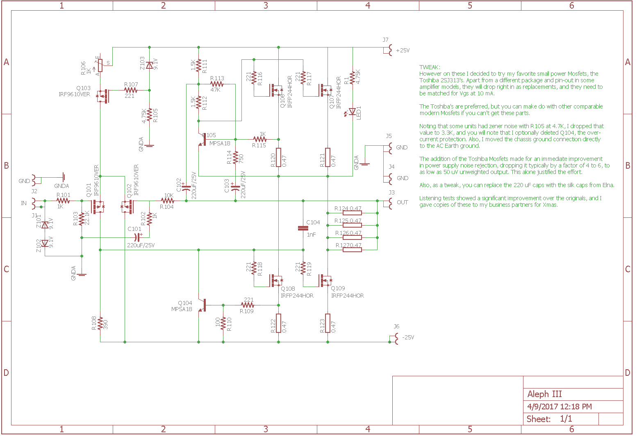
For work in original state, 1k trim (R106) need to be setup to 1k before mounting.
TWEAK (do it on your own responsibility):
Post from mr. Nelson on DIYaudio forum:
“You will perhaps remember that I previously posted an update to the Aleph 3 which incorporated Toshiba 2SJ109 Jfets on the input stage, and while this is still a worthy update there are two problems with it; first, it's difficult to get these parts, and second, they only work on the lower voltage amplifiers
which leaves out most of the other Alephs.

However on these I decided to try my favorite small power Mosfets, the Toshiba 2SJ313's. Apart from a different package and pin-out in some amplifier models, they will drop right in as replacements, and they need to be matched for Vgs at 10 mA.
The Toshiba's are preferred, but you can make do with other comparable modern Mosfets if you can't get these parts.
Noting that some units had zener noise with R105 at 4.7K, I dropped that value to 3.3K, and you will note that I optionally deleted Q104, the over-current protection. Also, I moved the chassis ground connection directly
to the AC Earth ground.
The addition of the Toshiba Mosfets made for an immediate improvement in power supply noise rejection, dropping it typically by a factor of 4 to 6, to as low as 50 uV unweighted output. This alone justified the effort.
Also, as a tweak, you can replace the 220 uF caps with the silk caps from Elna.

Listening tests showed a significant improvement over the originals, and I gave copies of these to my business partners for Xmas.”

